FULL ADDER

**EXP.NO: 23**

**AIM:**

To design and implement the full adder using Logisim simulator.

**PROCEDURE:**

1)      Pick and place the necessary gates.  
2)      Insert 3 inputs into the canvas.   
3)      Connect the inputs to the XOR gate, AND gate and OR gate.  
4)      Insert 2 outputs into the canvas.   
5)      Make the connections using the connecting wires.  
6)      Verify the truth table.

**TRUTH TABLE:**

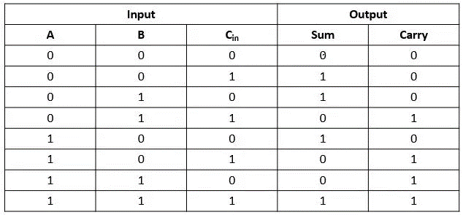

Sum=(A⊕B) ⊕Cin  
  
Carry=A.B+ (A ⊕B)

**OUTPUT**

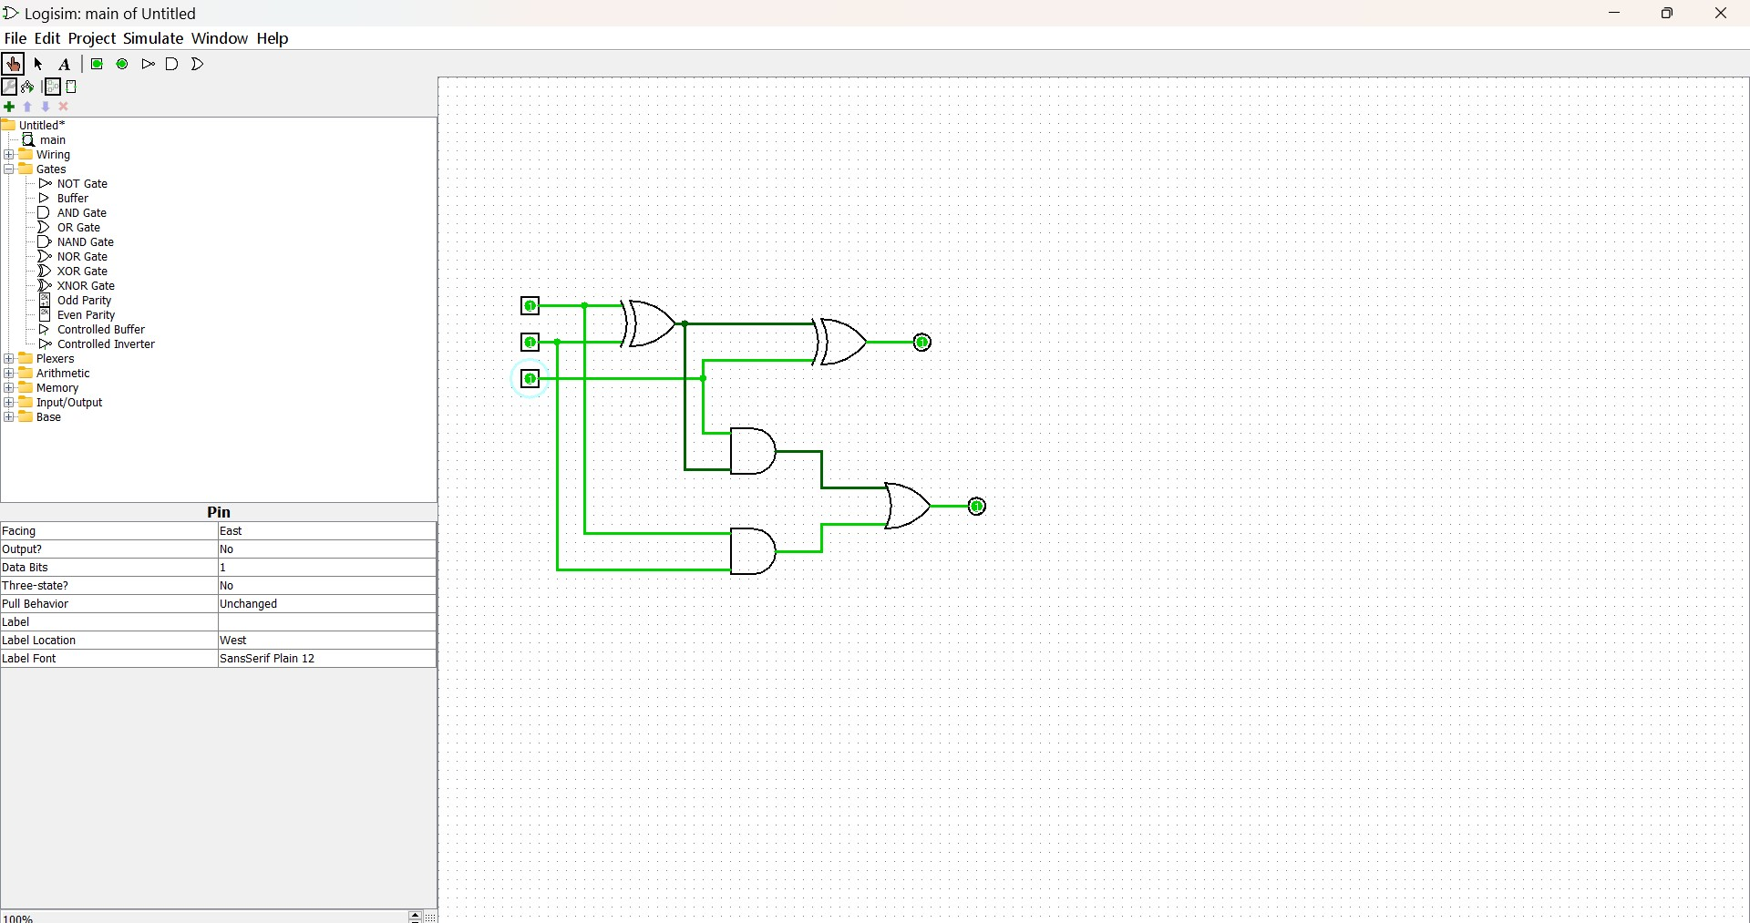

**RESULT:**

Thus full adder has been designed and implemented successfully using logisim simulator.